Special Olympics would like to acknowledge the sponsors who have contributed to this event.

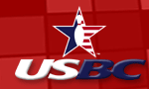

UNITED STATES BOWLING CONGRESS

Host Sponsor of the National Unified Bowling Tournament

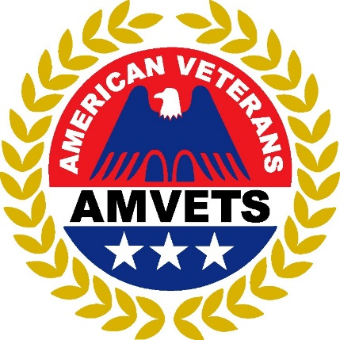

THE AMVETS NATIONAL SERVICE FOUNDATION

Co-Sponsor of the National Unified Bowling Tournament

